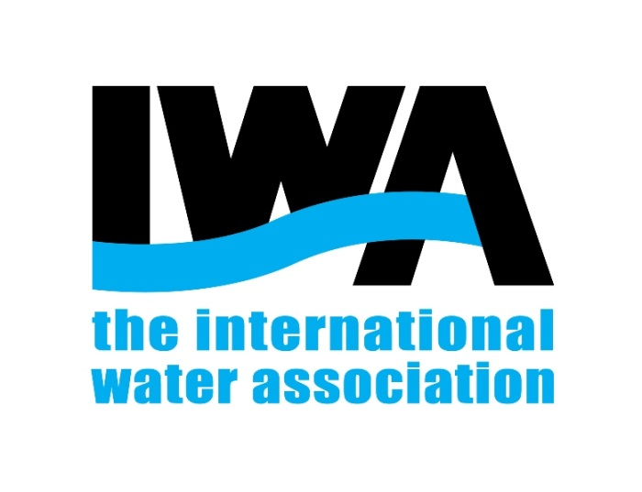

2025可持续城市水系统国际会议—预通知
国际水协会（International Water Association，IWA）是国际权威的水行业协会，致力于推动全球水资源的可持续管理。由IWA支持的2025年可持续城市水系统国际会议将以“构建韧性、包容与智慧的可持续水未来”（Resilient, Inclusive & Smart Water Futures）为主题，聚焦城市化进程中水系统面临的挑战与创新解决方案，推动跨学科、跨区域的学术交流与技术合作，助力实现联合国可持续发展目标（SDG 6）。
同济大学环境科学与工程学院联合IWA，共同主办本次高水平国际会议，旨在促进水务行业向碳中和、数字化与资源循环方向转型。

一、组织机构
主办单位：
- 同济大学环境科学与工程学院
- 可持续城市水系统国际联合研究中心
协办单位：
- 水污染控制与资源绿色循环全国重点实验室
- 长江水环境教育部重点实验室
- 上海污染控制与生态安全研究院
- 同济大学中德环境中心
会议支持：
- 国际水协会（IWA）

二、会议时间与地点
会议时间：2025年12月18日 - 12月20日
会议地点：中国·上海（具体会场地址待后续通知）
会议地址：将另行公布

三、大会日程概览
2025年12月18日
09:00-24:00 |  | 会议注册
14:00-17:00 |  | 可持续城市水系统国际联合研究中心学术委员会会议
 |  | IWA Young Professional Forum
 |  | Energy & Environmental Sustainability期刊编委会
2025年12月19日上午
开幕式
09:00-09:30 |  | 嘉宾致辞
09:30-11:30 |  | 主旨报告 & 特邀报告
2025年12月19日下午
分会场1：  水质安全与  数字化技术 | 分会场2：  绿色水处理与资源循环 |  | 分会场3：  水环境治理与健康城市 | 分会场4：  环境系统工程与风险控制 | 分会场6：  Energy & Environmental Sustainability期刊论坛
2025年12月20日上午
分会场1：  水质安全与  数字化技术 | 分会场2：  绿色水处理与资源循环 |  | 分会场3：  水环境治理与健康城市 | 分会场5：  先进环境技术产学研论坛 | 分会场7：  青年学生论坛
2025年12月20日下午
闭幕式
14:00-15:00 |  | 主旨报告
15:00-15:30 |  | 大会总结

四、参会注册与投稿
欢迎国内外学者投稿参会
投稿注册方式：会议网站在线注册或现场注册
投稿注册网址：（待后续通知发布）
注册费标准：
参会人员类型 | 注册费（人民币/元）
非国际水协会员 | 2000
国际水协会员 | 1800
学生 | 1500

Sustainable Urban Water Systems: Resilient, Inclusive & Smart Water Futures

--2025 International Conference Supported by IWA

International Water Association (IWA) is an authoritative water industry association, dedicated to promoting the sustainable management of global water resources. Supported by IWA, 2025 International Conference on Sustainable Urban Water Systems will be held under the theme "Resilient, Inclusive & Smart Water Futures." The conference will focus on the challenges and innovative solutions for urban water systems amidst rapid urbanization, fostering interdisciplinary and cross-regional academic exchange and technical cooperation to contribute to achieving UN Sustainable Development Goal (SDG) 6.
College of Environmental Science and Engineering, Tongji University, in conjunction with IWA, is jointly organizing this high-level international conference, aiming to promote the transition of the water sector towards carbon neutrality, digitalization, and resource circularity.

I. Organizers
Hosted by:
- College of Environmental Science and Engineering, Tongji University
- International Joint Research Center for Sustainable Urban Water Systems
Co-organized by:
- State Key Laboratory of Water Pollution Control and Green Resource Recycling
- Key Laboratory of Yangtze River Water Environment, Ministry of Education, China
- Shanghai Institute of Pollution Control and Ecological Security
- Sino-German Environmental Center, Tongji University
Supported by:
- International Water Association (IWA)

II. Date and Venue
- Conference Dates: December 18 - 20, 2025
Conference Location: Shanghai, China (Specific venue details to be announced in a subsequent notice)
Address: To be announced

III. Conference schedule
Thursday, December 18, 2025
09:00-24:00 |  | Conference Registration
14:00-17:00 |  | Academic Committee Meeting, International Joint Research Center for Sustainable Urban Water Systems
 |  | IWA Young Professional Forum
 |  | Editorial Board Meeting - Energy & Environmental Sustainability
Friday morning, December 19, 2025
Opening Ceremony
09:00-09:30 |  | Opening Remarks
09:30-11:30 |  | Keynote Speech & Invited Lecture
Friday afternoon, December 19, 2025
Session 1:  Water Quality Security and Digital Technology | Session 2:  Green Water Treatment and Resource Recycling |  | Session 3:  Water Environment Remediation and Healthy Cities | Session 4:  Environmental System Engineering and Risk Control | Session 6:  Journal Forum of Energy & Environmental Sustainability
Saturday morning, December 20, 2025
Session 1:  Water Quality Security and Digital Technology | Session 2:  Green Water Treatment and Resource Recycling |  | Session 3:  Water Environment Remediation and Healthy Cities | Session 5:  Industry-Academia-Research Forum | Session 7:  Youth Student Forum
Saturday afternoon, December 20, 2025
Closing Plenary
14:00-15:00 |  | Keynote Speech
15:00-15:30 |  | Conference Summary & Closing Ceremony

IV. Registration and Submission
Scholars from both China and abroad are warmly welcome to submit abstracts and attend the conference.
Registration & Submission Method: Online via the conference website or on-site registration.
Conference Website for Registration and Submission:
(To be announced)
Registration Fees:
Attendee Type | Fee (CNY)
Non-IWA Member | 2,000
IWA Member | 1,800
Student | 1,500

